**PROJECT REPORT**



**Project Name –** Text Extraction and Analyzer **Date:**



The 'Text Extraction and Analyzer' project serves as a valuable tool designed to efficiently extract information from diverse sources such as pamphlets, magazines, and papers that contain details about job vacancies. This tool utilizes advanced Natural Language Processing (NLP) techniques to analyze the extracted text comprehensively. By employing NLP, it can discern and categorize essential details such as the company name, job role, salary information, and contact details embedded within the extracted text.

This innovative system goes beyond mere extraction, incorporating a sophisticated analytical process that interprets the textual data. Through the application of NLP algorithms, the tool gains insights into the nuances of the information, ensuring a thorough understanding of the context. This capability allows the 'Text Extraction and Analyzer' to discern and extract critical details, facilitating the creation of a comprehensive summary.

**Problem identification - Design Thinking activities**

The 'Text Extraction and Analyzer' project addresses the inherent challenge of manually sifting through diverse textual sources, such as pamphlets, magazines, and papers, to identify and extract information related to job vacancies. The tool overcomes the problem of labor-intensive and time-consuming manual search and extraction by automating the process, providing a more efficient and effective means of gathering essential details from various advertisements.

* Automated extraction of job-related information from diverse textual sources
* Eliminates the need for manual and time-consuming searching through pamphlets, magazines, and papers
* Utilizes advanced Natural Language Processing (NLP) for comprehensive analysis of extracted text
* Categorizes crucial details like company name, job role, salary, and contact information
* Enhances efficiency by streamlining the identification and extraction process
* Provides users with a concise and coherent summary of job vacancies
* Facilitates informed decision-making for individuals seeking employment opportunities
* Offers a systematic solution to the challenge of individually locating and extracting information from various advertisements

**Problem Definition & Description**

In the realm of job vacancy discovery, individuals face a significant challenge in manually scouring diverse textual sources such as pamphlets, magazines, and papers. This process is time-consuming, labor-intensive, and often results in a lack of comprehensive and organized information. As a consequence, there is a pressing need for an automated solution that can efficiently extract and analyze relevant details from these sources, providing a streamlined and accessible overview of job opportunities.

**Description –**

The manual exploration of pamphlets, magazines, and papers for job advertisements poses a substantial obstacle for individuals seeking employment. This approach is not only inefficient but also prone to oversight, as crucial details may be scattered across numerous sources. The 'Text Extraction and Analyzer' project addresses this issue by offering an automated solution. By employing advanced Natural Language Processing (NLP) techniques, the tool extracts key information, including company names, job roles, salaries, and contact details. This automated approach eliminates the need for exhaustive manual searches, providing users with a consolidated and coherent summary of job vacancies. The problem at hand is thus mitigated by introducing a systematic and efficient method for extracting, organizing, and summarizing relevant information from varied textual sources.

The manual search for job vacancies in traditional mediums such as pamphlets, magazines, and papers presents a multifaceted challenge. Job seekers often find themselves grappling with the tedious and time-consuming task of sifting through a myriad of textual content, leading to potential oversight of valuable opportunities. Moreover, the scattered nature of information across different sources compounds the difficulty in obtaining a comprehensive understanding of available job positions.

**Idea Generation**

1. **Evolution of Idea:**

The conception of the 'Text Extraction and Analyzer' project stemmed from a recognition of the inherent challenges faced by individuals in the process of seeking employment through traditional mediums. The idea evolved through the following stages:

1.Identification of Manual Search Challenges:

Initial observations highlighted the cumbersome nature of manually searching through pamphlets, magazines, and papers for job advertisements.

The realization that this approach is time-consuming, prone to oversight, and lacks efficiency prompted the exploration of technological solutions.

2. Exploration of Automation Possibilities:

The idea evolved towards leveraging automation to streamline the extraction of relevant information from textual sources.

Automation was seen as a means to not only expedite the search process but also to ensure a more thorough and systematic analysis of job-related details.

3. Integration of Natural Language Processing (NLP):

Recognizing the power of NLP in understanding and interpreting textual content, the idea evolved to incorporate advanced NLP techniques.

NLP became a crucial component in the project, enabling the tool to not only extract information but also to comprehend the nuances and context of the text.

4. Holistic Information Extraction:

The project's evolution involved a shift towards not just extracting data but also categorizing and summarizing it comprehensively.

This holistic approach aimed to provide users with a consolidated and easily understandable summary of job opportunities, addressing the scattered nature of information in traditional sources.

5. Emphasis on User Empowerment:

The evolution of the idea emphasized empowering users with a tool that not only automates the search process but also enhances their decision-making capabilities.

The goal became to offer a user-friendly solution that transforms the job-seeking experience by providing organized and insightful summaries of available opportunities.

6. Refinement through Iterative Feedback:

The idea underwent refinement through iterative feedback loops, involving testing and improvements based on user experiences and changing technological landscapes.

This iterative process ensured that the 'Text Extraction and Analyzer' project continued to align with the evolving needs of job seekers in a dynamic environment.

The evolution of this idea reflects a commitment to addressing the challenges inherent in traditional job search methods and embracing technology to create a more efficient, insightful, and user-centric solution.

1. **Existing solutions & Challenges:**

Existing Solutions:

1. **Job Search Platforms:**

Traditional online job search platforms like LinkedIn, Indeed, and Glassdoor provide a centralized database of job listings.

Users can search for jobs based on various criteria, and these platforms often include features like resume uploading and networking opportunities.

1. **Automated Resume Parsing:**

Some tools focus on extracting information from resumes automatically, streamlining the application process for job seekers and recruiters.

These solutions aim to improve efficiency in candidate screening and selection.

1. **NLP-Powered Job Matching:**

Advanced applications utilize Natural Language Processing (NLP) to match job descriptions with resumes, enhancing the accuracy of job recommendations.

These systems aim to improve the relevance of job matches for both employers and job seekers.

**Challenges:**

1. **Information Scattering:**

In traditional media like pamphlets and magazines, job information is often scattered, making it challenging to extract and compile details efficiently.

1. **Diversity of Formats:**

Job advertisements come in diverse formats, making it difficult for automated systems to uniformly extract information.

The lack of standardized structures poses a challenge for effective data extraction.

1. **Quality of Data:**

Extracted information may vary in quality, leading to potential inaccuracies or incomplete details.

Ensuring the accuracy and completeness of extracted data remains a persistent challenge.

1. **Privacy Concerns:**

Handling personal and contact information in job listings requires careful consideration of privacy concerns.

Ensuring compliance with data protection regulations poses an ongoing challenge for job search platforms and automated tools.

1. **Integration with Legacy Systems:**

Some organizations still rely on legacy systems for job posting and recruitment.

Integrating modern solutions with these legacy systems can be a technical challenge, hindering the seamless adoption of new technologies.

1. **Continuous Adaptation to Industry Changes:**

The job market evolves, and new industries and roles emerge.

Keeping automated systems up-to-date and adaptable to changing job market dynamics is an ongoing challenge.

1. **User Adoption and Interface Design:**

The success of these tools relies on user adoption, and designing user-friendly interfaces is crucial.

Ensuring that the technology is accessible and intuitive for users with varying levels of technological proficiency presents a design challenge.

Addressing these challenges requires a holistic approach that combines technological innovation, regulatory compliance, and a keen understanding of user needs. The evolution of existing solutions will likely involve continuous improvements in automation, data quality, and user experience to meet the dynamic demands of the job-seeking landscape.

**Design :**

In the design phase of the 'Text Extraction and Analyzer' project, careful consideration is given to creating a robust and user-centric solution that effectively addresses the identified challenges in traditional job search methods. The design encompasses key elements to ensure efficiency, accuracy, and a seamless user experience.

**1. System Architecture:**

The system is designed with a modular and scalable architecture, allowing for flexibility in accommodating diverse sources of textual information. This includes pamphlets, magazines, and papers, ensuring adaptability to different formats.

**UI of the Project**

1. **Drag and Drop :**

Utilizing the drag-and-drop user interface created, users can seamlessly uploadimage files of varying formats, including PNG and JPG. This intuitive interaction method simplifies the process of adding images to the system. Users can effortlessly drag an image file from their desktop or file explorer and drop it onto the designated area in the user interface. The system intelligently recognizes and processes the uploaded image, regardless of its format, ensuring a versatile and user-friendly experience. This functionality not only enhances accessibility but also accommodates the diverse preferences of users when dealing with image files, contributing to a more streamlined and efficient workflow.

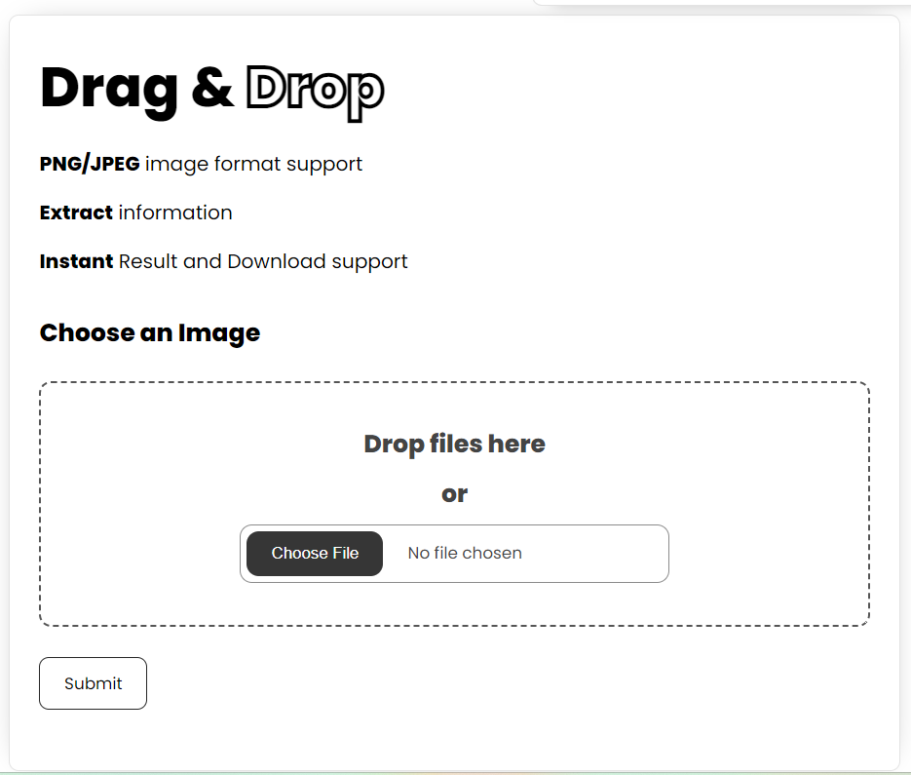

1. **NavBar :**

The navigation bar, skillfully developed using Flask, serves as a central element in facilitating seamless transitions between different pages. With a combination of class colors and a visually appealing user interface, this navbar enhances the overall aesthetic and user experience. Users can effortlessly navigate to various sections, including Home, About, and Contributors, by interacting with the intuitively designed navigation bar. The incorporation of stylish design elements and Flask's functionality not only ensures smooth page transitions but also adds an element of sophistication to the overall user interface, contributing to a visually engaging and user-friendly web environment.



1. **Extracted Results :**

Upon completion of the comprehensive workflow, encompassing text extraction, NLP preprocessing, parsing, and other essential steps, the extracted information will be presented in a structured tabular format. This organized presentation ensures that users can easily and efficiently access the processed data, enabling a clear and coherent representation of the insights derived from the intricate processes of text extraction and NLP analysis. The tabular format not only enhances readability but also provides a user-friendly interface for reviewing and interpreting the synthesized information.

Once the intricate steps of text extraction, NLP preprocessing, parsing, and other essential procedures have been successfully executed, users can expect the culmination of this process to manifest in a user-friendly tabular format. This tabular presentation is meticulously designed to showcase the extracted information in a structured manner, allowing for convenient analysis and interpretation. Each row of the table likely corresponds to a specific piece of information, such as job details, company specifics, or contact information, while columns represent distinct attributes or categories.

This structured tabular format not only facilitates a systematic overview but also streamlines the exploration of critical insights derived from the initial data. Users can efficiently navigate and comprehend the organized data, leveraging the clarity and coherence provided by the tabular presentation. The visual representation enhances the accessibility of information, ensuring that users can quickly discern key details and make informed decisions based on the extracted and processed data. In essence, the tabular format serves as the final stage of presenting the enriched information, offering a user-centric and efficient means of engaging with the outcomes of the text extraction and NLP analysis.

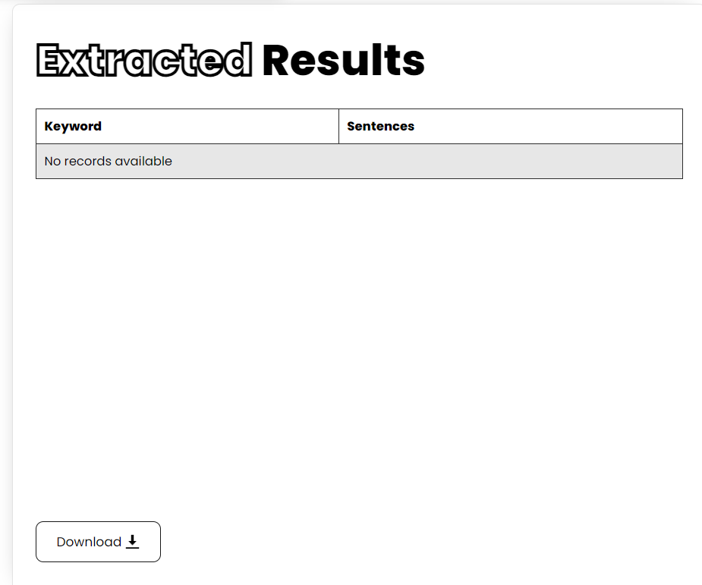



**Download option :** It Downloads the Extracted table or information in the form of CSV or Excel .

1. **About Page :**

The 'About' page serves as an informative hub, offering users insights into the intricate processes and functionalities behind the system's core features. Here, users can delve into an explanation of how the text extraction, NLP preprocessing, parsing, and other crucial steps work synergistically to distill valuable information from diverse textual sources. This page provides a narrative that not only outlines the technical aspects of the system but also underscores its user-centric approach.

Visitors to the 'About' page will gain a deeper understanding of how the structured tabular format, resulting from these processes, becomes the central interface for accessing and comprehending the extracted information. By providing this context, the 'About' page transforms into a comprehensive guide, ensuring users not only navigate the system seamlessly but also appreciate the underlying methodologies that contribute to the efficiency and user-friendliness of the overall experience.

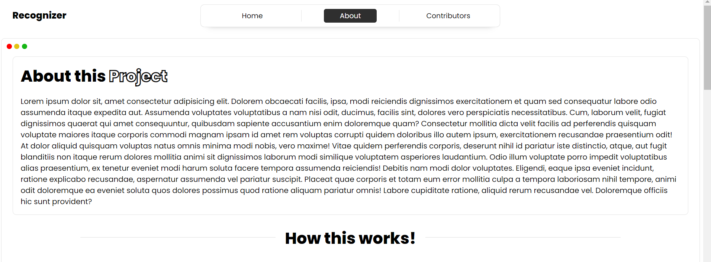

1. **Contributors Page :**

The 'Contributors' page serves as a dedicated space to acknowledge and showcase the talented developers who contributed to the realization of the above project. Here, users can explore detailed profiles and learn more about the individuals behind the scenes, gaining insights into their expertise, roles, and unique contributions. This page offers a comprehensive overview of the diverse skill sets and collaborative efforts that brought the project to fruition.Visitors to the 'Contributors' page will find a curated compilation of developer profiles, highlighting the collective dedication and innovation that each team member brought to the project. Through this insightful showcase, users can appreciate the collaborative synergy that has been instrumental in shaping the project's success, fostering a sense of transparency and gratitude towards the individuals who played pivotal roles in its development.

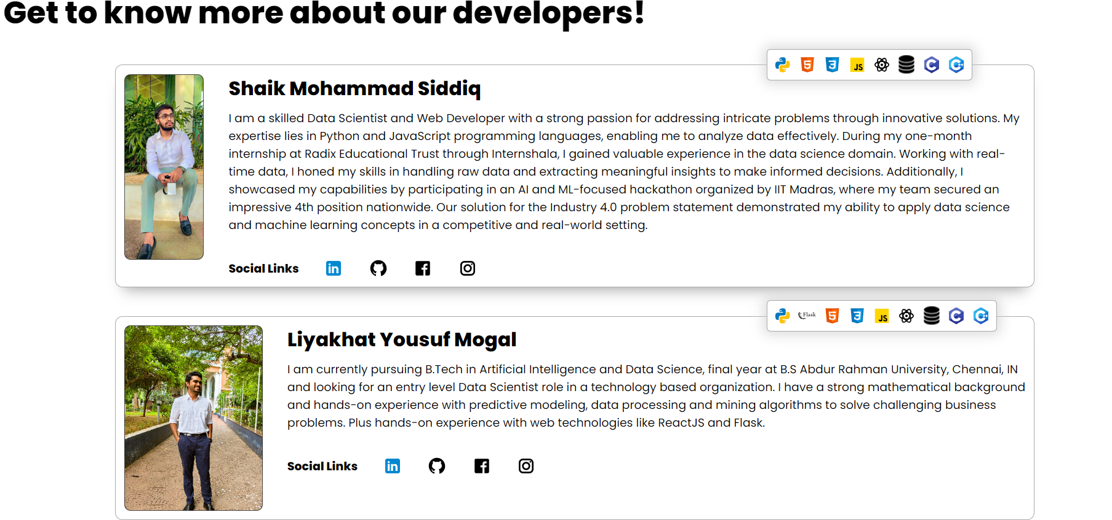

**Implementation of model :**

The implementation of the aforementioned project leverages a robust combination of HTML, CSS, JavaScript, and Flask. HTML serves as the foundation for designing the user interface (UI), providing the structural elements necessary for an intuitive and visually appealing layout. CSS is employed to enhance the aesthetic appeal by styling the UI elements, ensuring a cohesive and engaging presentation.

JavaScript plays a pivotal role in adding functionality to the project, with specific features such as drag and drop capabilities. This dynamic scripting language contributes to the interactive aspects of the user interface, fostering a seamless and responsive user experience. The utilization of JavaScript goes beyond mere aesthetics, introducing essential functionalities that enhance user interactions and streamline processes.

Flask, a powerful web framework, is integrated into the implementation to manage routing and server-related functionalities. Its role extends to handling requests, managing data flow, and ensuring the seamless communication between the front-end and back-end components of the project. Flask's versatility and efficiency make it a key component in creating a robust and well-integrated web application.

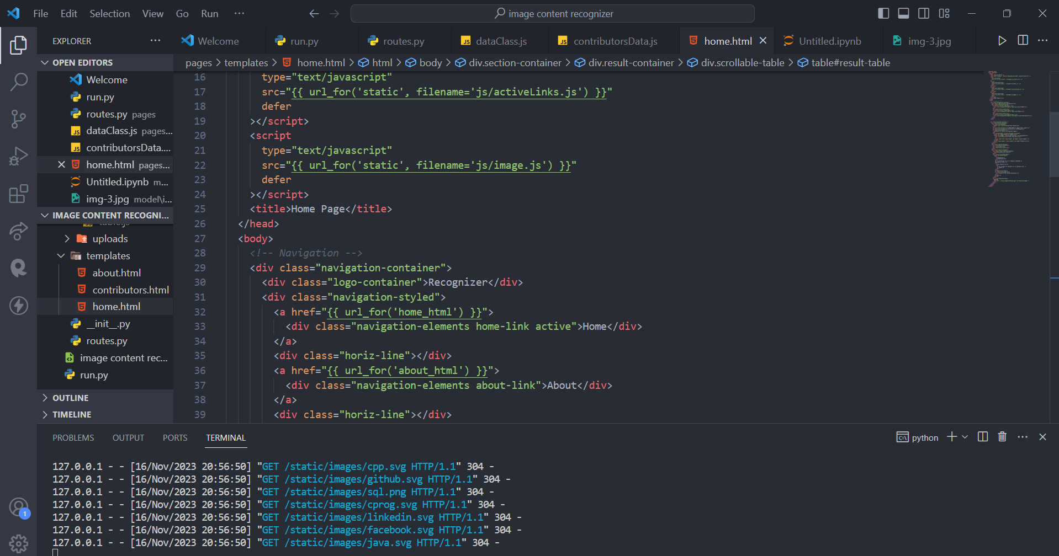

**Sprint 1: Project Kickoff and Planning**

In the inaugural sprint, the focus lies on project initiation and meticulous planning. This involves defining the scope, objectives, and key features of the 'Text Extraction and Analyzer' project. The team collaboratively outlines user stories, establishes the project timeline, and assigns roles and responsibilities. Initial wireframes for the UI are sketched, providing a foundational blueprint for subsequent sprints.

**Sprint 2: UI Design and HTML Integration**

With a clear understanding of the project's scope, the second sprint concentrates on UI design and HTML integration. Designers work on creating aesthetically pleasing and user-friendly interfaces, while developers start implementing these designs using HTML. This sprint establishes the fundamental structure of the user interface, setting the stage for subsequent enhancements.

**Sprint 3: CSS Styling and Initial JavaScript Functionality**

Building upon the HTML foundation, the third sprint introduces CSS styling to enhance the visual appeal of the UI. Simultaneously, initial JavaScript functionalities are incorporated to enable basic user interactions, such as navigation and form handling. This sprint marks the transition from a static layout to a more dynamic and responsive interface.

**Sprint 4: Flask Integration for Routing**

Sprint four is dedicated to integrating Flask, the web framework, for server-side operations and routing. The team sets up the Flask environment, establishes routes for different pages, and ensures seamless communication between the front-end and back-end components. This sprint lays the groundwork for handling user requests and managing data flow within the application.

**Sprint 5: Advanced JavaScript Functionality and NLP Integration**

Building on the initial JavaScript functionalities, the fifth sprint introduces more advanced features, such as drag-and-drop capabilities. Additionally, the team begins integrating Natural Language Processing (NLP) techniques into the project, enhancing the system's ability to analyze and process extracted text comprehensively.

In essence, the collaborative use of HTML, CSS, JavaScript, and Flask forms a cohesive technological stack, with each component playing a distinct and

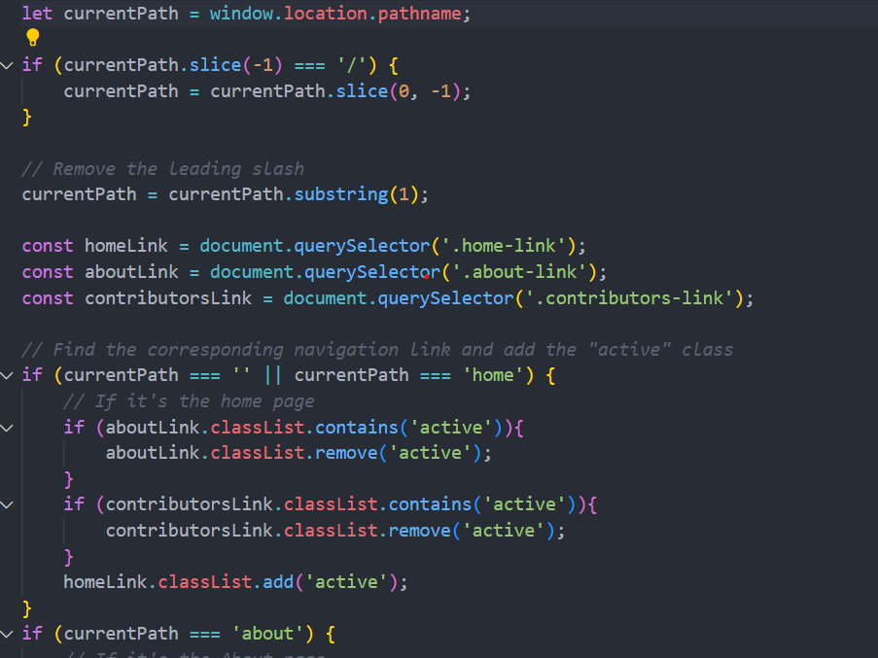

complementary role in bringing the envisioned project to life. This amalgamation ensures a harmonious blend of design, functionality, and server-side operations, resulting in a cmprehensive and effective solution.

**Result**

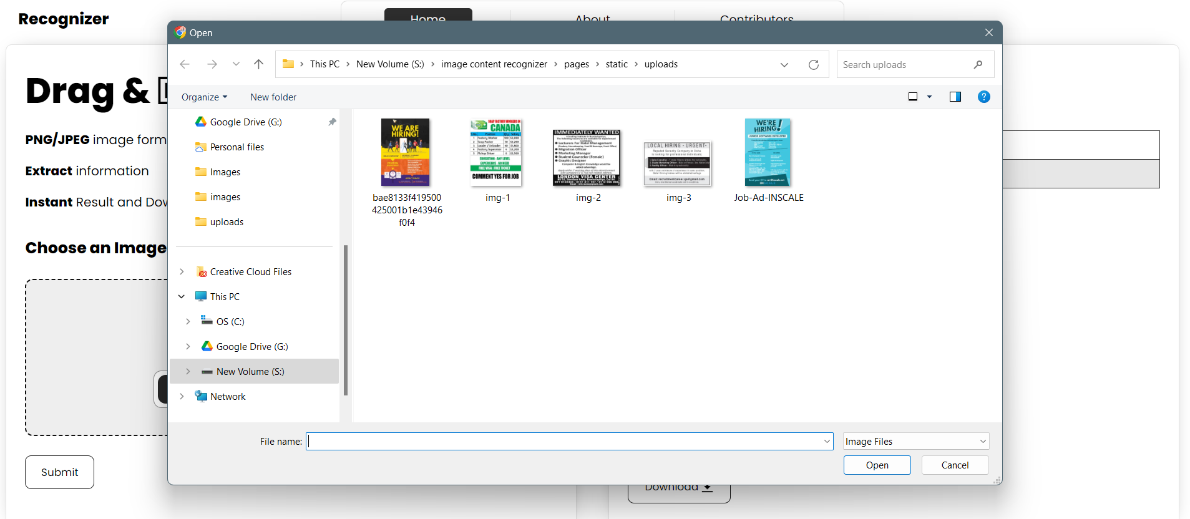

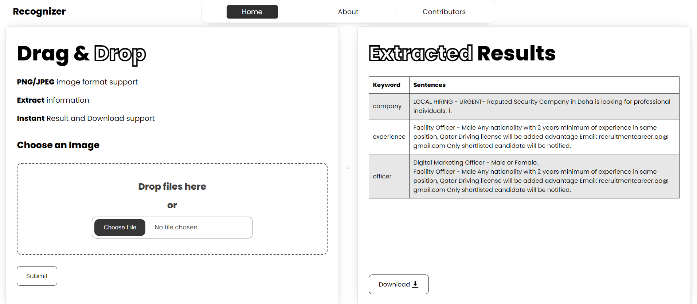

**Deployment :**

Deploying a Flask model on Google Cloud involves several steps. Below is a high-level overview of the process:

1. Set Up a Google Cloud Platform (GCP) Account:

Create a Google Cloud account if you don't have one.

Set up a new project on the Google Cloud Console.

2. Install and Configure Google Cloud SDK:

Download and install the Google Cloud SDK on your local machine.

Configure the SDK with your GCP credentials using the gcloud auth login command.

3. Set Up Your Flask Application:

Ensure your Flask application is modular and follows best practices.

Make sure your Flask app is working locally.

4. Containerize Your Flask App:

Create a Dockerfile in the root of your project to containerize your Flask app.

Build a Docker image of your application using docker build.

Push the Docker image to Google Container Registry (GCR).

5. Create a Kubernetes Cluster:

Use Google Kubernetes Engine (GKE) to create a Kubernetes cluster.

Configure kubectl to use the newly created cluster.

6. Deploy Flask App to Kubernetes:

Create Kubernetes deployment and service YAML files to describe your app's deployment.

Deploy your Flask app to Kubernetes using kubectl apply -f your-deployment.yaml.

7. Expose Your Service:

Expose your Flask app to the internet by creating a Kubernetes service.

Obtain the external IP address for your service.